Literature Review
Tony Imbierski
Version: Draft 0.1 30 dec 2020

This project will be looking at DNS over HTTPS (DoH), a recent technology standardised by IETF RFC 8484 in October 2018. According to this RFC, DNS queries can be encoded into BASE64-url representation and then sent as an HTTP request using either the GET or POST requests of HTTP. Since there already exists a standard to allow HTTP to transport across secure TLS connections (HTTPS) this means that DNS queries can be sent to servers like any other secure web traffic.
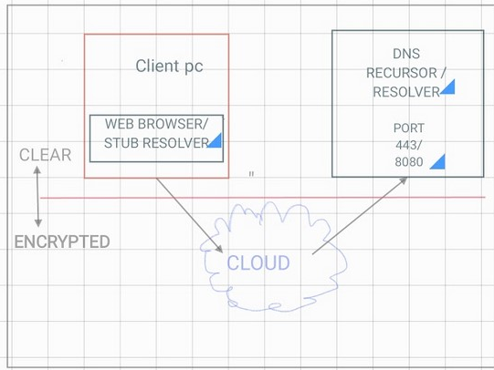

The DNS query is in standard DNS wire format with the header, question and response sections as in any normal DNS query. This is then encoded into base64-url representation which ensures that only web-safe characters are used in the transmitted packet. This packet is then made part of an HTTP GET or POST request. If GET, the DNS request is encoded as a URI parameter, if POST then the DNS request is added as post content along with its length. The exact URI in use is not defined in RFC 8484, but left as an implementation variable. The DoH server must be configured with a URI template that specifies the base URL plus the name of the parameter to use for GET requests. The headers of the request must show that the application accepts a return type of application/dns-message. The final HTTP(s) sequence is then sent over a TLS connection to the standard listening port of TCP443 (or sometimes alternative 8080).
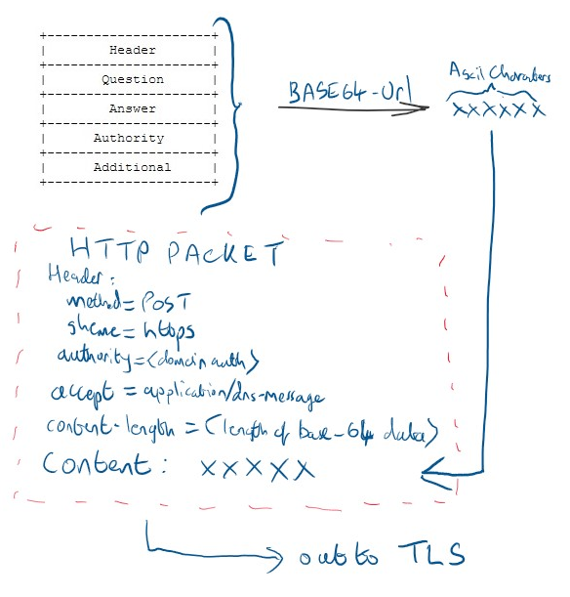

All data passed through the connection between the client and DNS resolver is encrypted under TLS, so only the parties at each end can see the target of the DNS query. This ensures that the primary request from the client is confidential, however note that it does not guarantee that the downstream queries from the resolver to the various authoritative servers are equally secured.
RFCs can vary in their penetration and speed of adoption (e.g. DNSSEC). DoH currently shows signs of potentially faster deployment, as the Mozilla Firefox and Google Chrome browsers have already incorporated the functionality, and Mozilla have made it a default setting in the US. Microsoft have also announced DoH support in the Windows 10 OS. Taken together these actors represent a large portion of internet traffic that could potentially be using DoH if the option is enabled by default.
A big driving factor behind DoH is the concern over big data acquisition and internet privacy. DNS is one of the few remaining internet protocols where it is perfectly normal to transmit data in clear text, meaning that a user’s browsing history is open to eavesdropping even if the traffic to the websites themselves in encrypted. European case law now considers that IP addresses count as ‘personal data’ in some circumstances. It is possible to trace private citizens’ browsing histories by maintaining logs of DNS queries, which for most will normally be handled by their Internet Service Provider (ISP). Whilst DNSSEC was concerned only with integrity of DNS information, DoH provides all three aspects of the CIA triad, and, at least in theory, prevents such data tracking as the queries are encrypted.
The introduction of DoH has generated controversy, more so than previous attempts to secure the DNS system. There are two main areas of contention: that DoH can thwart security controls (parental locks, malware detection etc.) that rely on inspection of DNS requests for their operation; and that DoH (especially as implemented by Mozilla) simply concentrates the personal information in the hands of a small number of service providers. Mozilla’s default DoH provider is Cloudflare, and Mozilla claim that Cloudflare (and other providers it partners with) are bound to ethical behaviour because they signed up to Mozilla’s Trusted Recursive Resolver program.
Whether Cloudflare actually realise a near-monopoly position in DNS traffic and whether they use this to commercial advantage are probably beyond scientific study: we’ll just have to wait and see. However an observer of how large corporations handle big data when they have access to it does not give grounds for optimism.
Focussing therefore on the security controls aspect, we can asses that the impact may vary according to situation. In corporate or enterprise networks, the situation may possibly be mitigated by locking down client machines to use local resolvers that can decode the DoH request before passing it on thereby offering a point of inspection and control. This is possible because such environments have a high degree of physical control over both network and nodes.
Outside of the corporate environment things are not so easy. Most end users will be unlikely to adjust the default settings of their browser, either through ignorance or lack of interest. Therefore any move to introduce a single default DoH provider by the browser developers are likely to have a large impact.

https://tools.ietf.org/html/rfc8484
https://tools.ietf.org/html/rfc4648
https://tools.ietf.org/html/rfc2818
https://tools.ietf.org/html/rfc1035
Song, Yo-Der (01/07/2019). "Understanding Evolution and Adoption of Top Level Domains and DNSSEC" in 2019 IEEE International Symposium on Measurements & Networking (M&N) (1-72811-274-5, 978-1-72811-274-9), (p. 1).
An End-to-End, Large-Scale Measurement of DNS-over-Encryption: How Far HaveWe Come? Chaoyi Lu1,2, Baojun Liu3, et al 2019
https://blog.mozilla.org/netpolicy/2020/02/25/the-facts-mozillas-dns-over-https-doh/
https://techcommunity.microsoft.com/t5/networking-blog/windows-will-improve-user-privacy-with-dns-over-https/ba-p/1014229
DNS privacy in practice and preparation CoNEXT '19: Proceedings of the 15th International Conference on Emerging Networking Experiments And Technologies December 2019
CJEU Case 582/14 – Patrick Breyer v Germany
https://tools.ietf.org/html/rfc4033
https://www.zdnet.com/article/dns-over-https-causes-more-problems-than-it-solves-experts-say/
https://www.zdnet.com/article/mozilla-cloudflare-doesnt-pay-us-for-any-doh-traffic/
https://blog.mozilla.org/netpolicy/2019/12/09/trusted-recursive-resolvers-protecting-your-privacy-with-policy-technology/

